**Full Stack Development Day 7**

**Assignment Problem Solutions**

1. **Validation of Date of Birth**

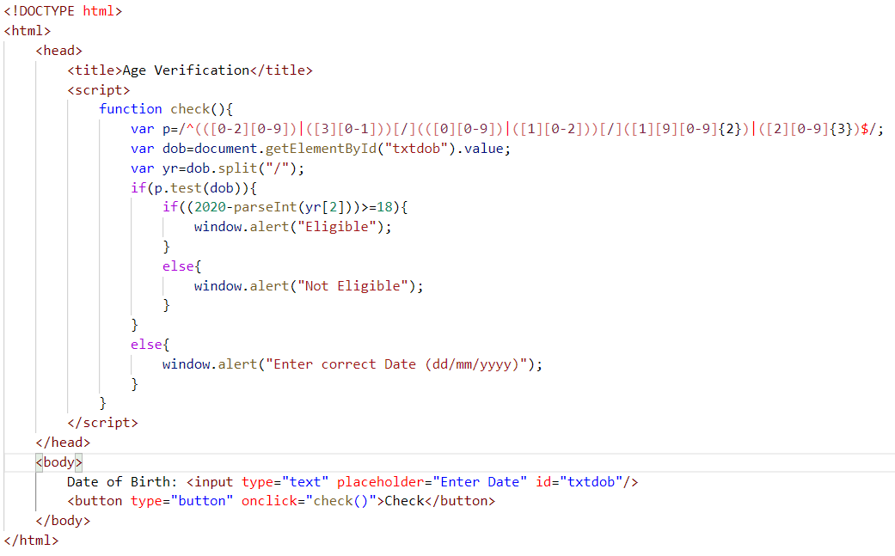

1. **Validation of Password contains 1 Lower case, 1 Upper case and 1 Digit**

**Regular Expression**

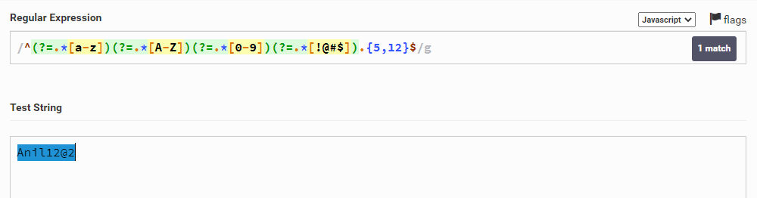

**Validate using javascript Function**

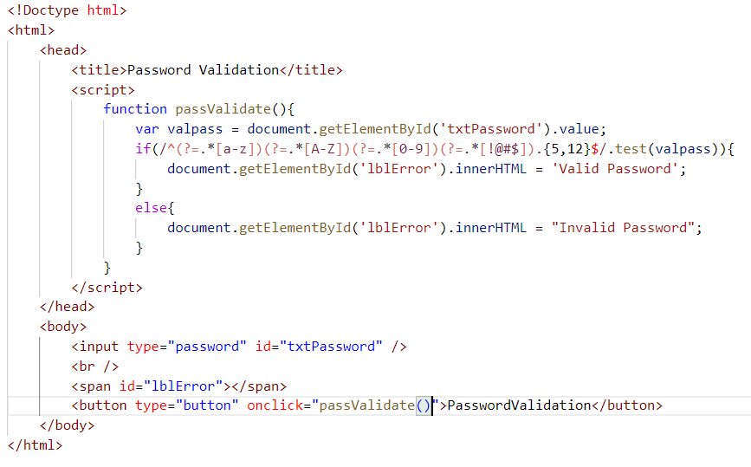

**Sample Project on Javascript Validation**

**Step 1:**

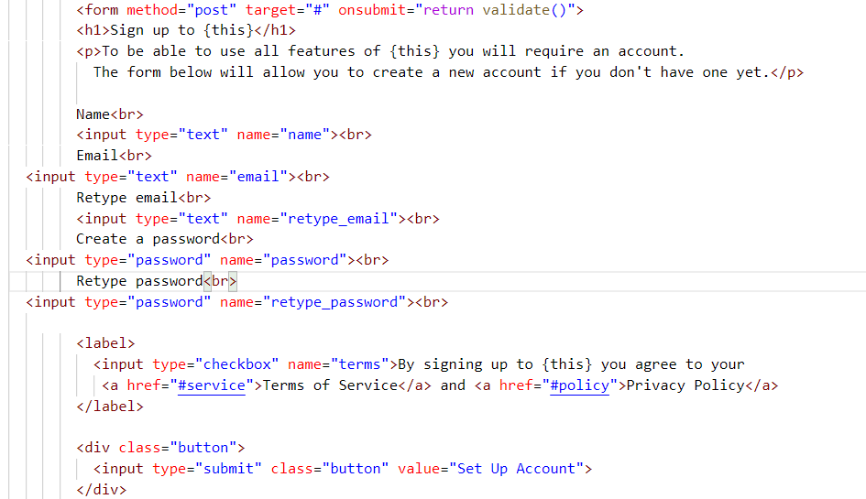

**Step 2:**

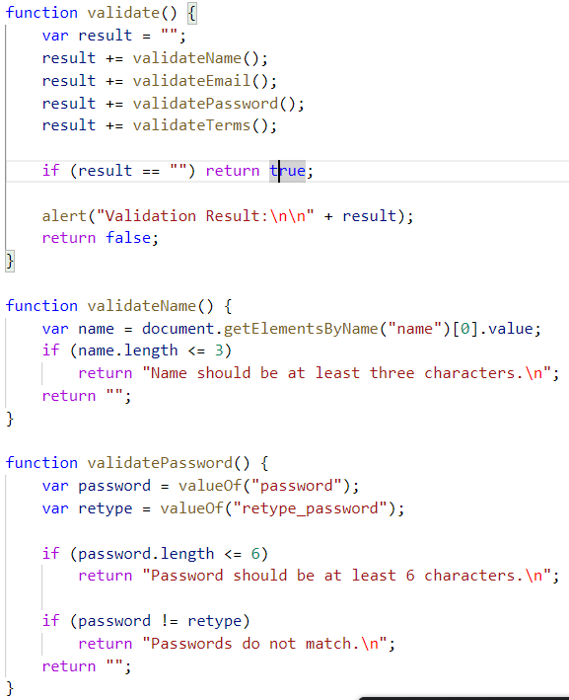

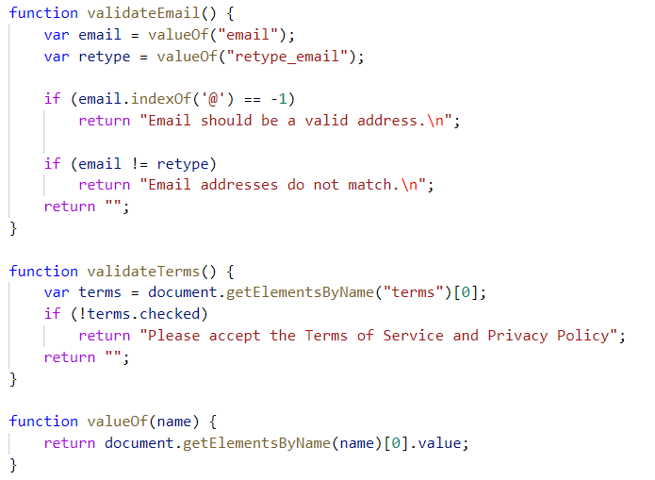

**Step 3:**

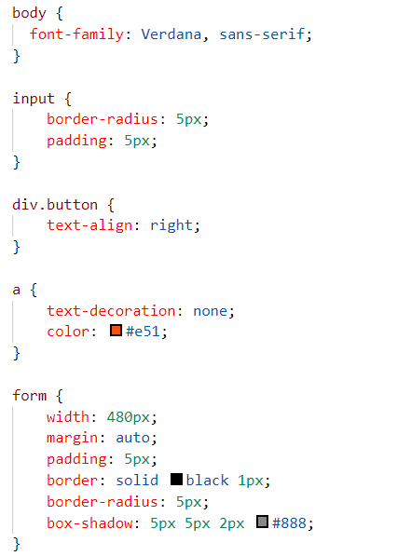

Summary Javascript:

1. Javascript can be used as Client Side Scripting
2. Javascript is one the of the primary Web Programming
3. Javascript makes less round trips (request and response) to the server so that application performance will be increased
4. Client Side scripting will reduce the burden on servers.

**Bootstrap**

**Version 4.0**

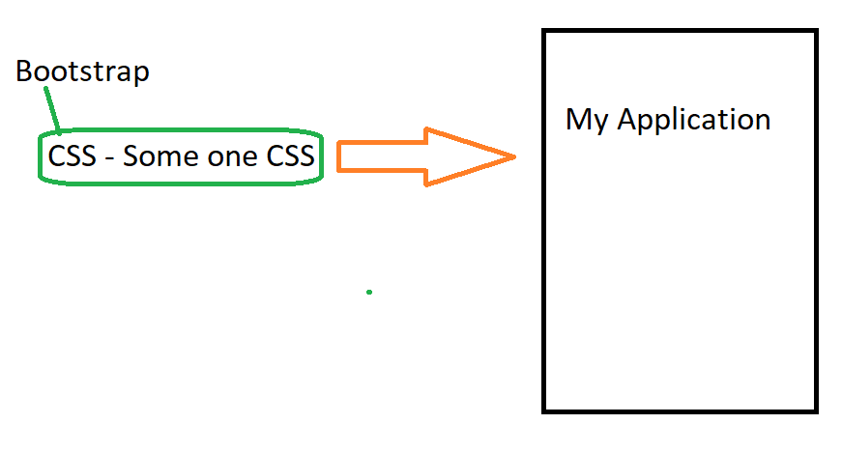

1. Bootstrap is one of the front end frameworks for faster and easier web applications
2. Bootstrap is CSS Framework that gives better and effective web application designs
3. Bootstrap is used for responsive designs (It can fit to any device like mobile, tablet, laptop and desktop) and it have browser compatibility also (Firefox, Chrome, Internet Explorer 10+ and safari)

**How to Get this Bootstrap to My Application**

1. Bootstrap CDN(Content Delivery Network)
2. Download from getboostrap.com

**Min.extension as min.css and min.js , Minification means it will remove the white spaces in the given source file**

**Let’s get started with Bootstrap:**

1. **Container class**

**Container and container-fluid**

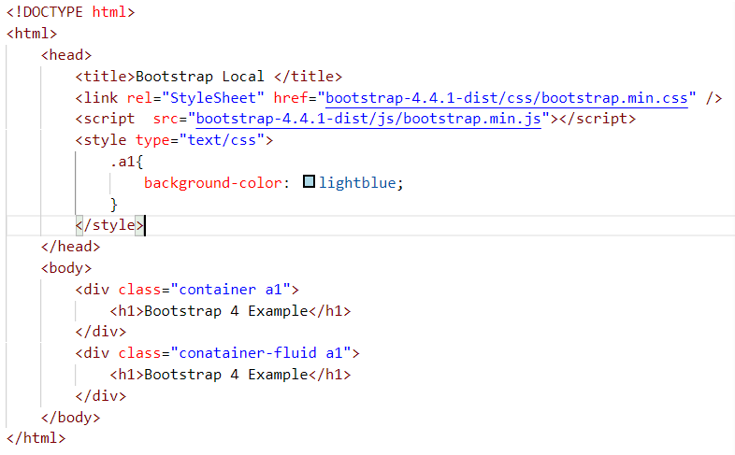

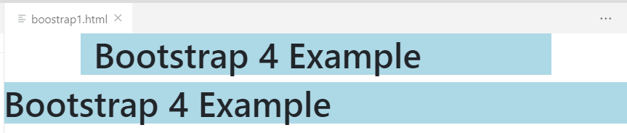

**Bootstrap 4 Grid Formatting**

